**Calculator Assumed**

**Counting Techniques and Probability - Combinations**

Time: 45 minutes

Total Marks: 45

Your Score: / 45



**Question One: [1 mark]**

Lina wants to create a playlist of 20 songs to listen to while she exercises. She has narrowed down her music collection to 35 possible song tracks. How many different playlists can she make, assuming that the order of songs in the list is not important?

**Question Two: [1, 6 = 7 marks]**

Tom has 5 notes in his wallet: $100, $50, $20, $10 and $5.

1. If he chooses two at random, how many combinations can he make?
2. If he chooses three at random, how many combinations contain:

(i) a $5 note?

(ii) no $50 note?

(iii)either a $100 note or a $50 note?

**Question Three: [1, 12 = 13 marks]**

Below is a menu for a New Year’s Eve dinner.

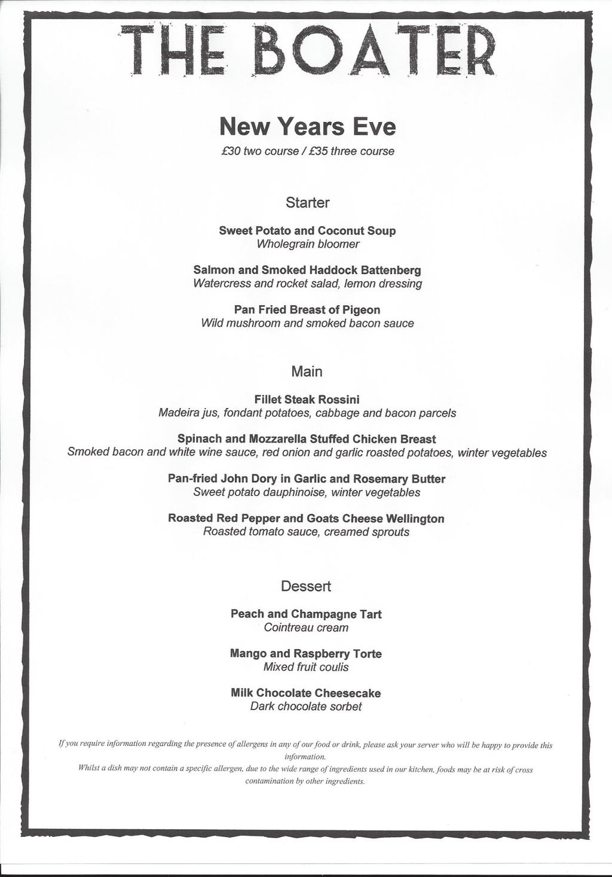

Use the menu to answer the following questions.

1. If there are no restrictions, how many possible three course dinner combinations can be chosen from this menu?
2. Determine the probability that the chosen three course meal:

(i)is suitable for a vegetarian.

(ii) contains no seafood.

1. contains the pigeon starter and the chocolate dessert.
2. contains the fillet steak or the soup.
3. contains the peach tart, given that the chicken breast was chosen as a main.

**Question Four: [2, 2, 2, 1, 2 = 9 marks]**

In Saturday Lotto, players choose six different numbers from the numbers 1 to 45 inclusive. If those same six numbers are drawn from the ball wheel then they win first division, which is usually a $2 000 000 prize each draw.

1. What is the probability that a player who chooses just 6 numbers, i.e. they play just one game, wins first division?
2. If a player buys a Slikpik 18, a computer generated ticket with 18 games, each of 6 different numbers, what is the probability the player wins first division?
3. Richard is playing one game of Saturday Lotto. So far he has the first two numbers on the balls that have been drawn, 3 and 27. What is the probability that he will win first division?

Mireille has come up with an ingenious plan to win the Lotto Jackpot. She decides that she will spend a year writing out all the possible combinations of numbers to win Saturday Lotto and play them all when the $30 million Jackpot is scheduled for the 30th December.

1. If each game costs $0.71 to play, how much money would she need to play all games?
2. Mireille managed to complete her plan and entered all possible combinations into that 30th December draw. There were 19 first division winners in that draw, including Mireille, and the $30 million had to be shared equally between them all. How much money did Mireille lose?

**Question Five: [2, 4, 9 = 15 marks]**

To attend the Senior School Have Sum Fun competition, Summer Heights High (SHH) have to send a team of 7 elite mathematics students (2 Year 12 students, 2 Year 11 students, 2 Year 10 students, 1 student as reserve) and 1 teacher.

SHH have the following students willing to go:

5 Year 12 students: Homer, Ralph, Bart, Lisa and Marge.

3 Year 11 students: Daisy, Mickey and Donald.

4 Year 10 students: Sheldon, Leonard, Penny and Amy.

Mr Mulder and Miss Scully are the two teachers available to attend the competition.

1. How many possible teams (including the teacher) can SHH send?
2. How many possible teams (including the teacher) can SHH send if Mr Mulder is ill and unable to attend and Leonard will only attend if Penny does?
3. Ignoring all previous restrictions, determine the probability that:

(i) Mickey and Homer are on the team.

(ii) Ralph is on the team given that Mr Mulder attends.

(iii) Either Sheldon or Daisy are on the team, given that Sheldon is on the team.

**SOLUTIONS**

**Calculator Assumed**

**Counting Techniques and Probability - Combinations**

Time: 45 minutes

Total Marks: 45

Your Score: / 45



**Question One: [1 mark]**

Lina wants to create a playlist of 20 songs to listen to while she exercises. She has narrowed down her music collection to 35 possible song tracks. How many different playlists can she make, assuming that the order of songs in the list is not important?



**Question Two: [1, 6 = 7 marks]**

Tom has 5 notes in his wallet: $100, $50, $20, $10 and $5.

1. If he chooses two at random, how many combinations can he make?





1. If he chooses three at random, how many combinations contain:

(i) a $5 note?



(ii) no $50 note?



(iii)either a $100 note or a $50 note?





**Question Three: [1, 12 = 13 marks]**

Below is a menu for a New Year’s Eve dinner.



Use the menu to answer the following questions.

1. If there are no restrictions, how many possible three course dinner combinations can be chosen from this menu?



1. Determine the probability that the chosen three course meal:

(i)is suitable for a vegetarian.



(ii) contains no seafood.



1. contains the pigeon starter and the chocolate dessert.



1. contains the fillet steak or the soup.



1. contains the peach tart, given that the chicken breast was chosen as a main.





**Question Four: [2, 2, 2, 1, 2 = 9 marks]**

In Saturday Lotto, players choose six different numbers from the numbers 1 to 45 inclusive. If those same six numbers are drawn from the ball wheel then they win first division, which is usually a $2 000 000 prize each draw.

1. What is the probability that a player who chooses just 6 numbers, i.e. they play just one game, wins first division?





1. If a player buys a Slikpik 18, a computer generated ticket with 18 games, each of 6 different numbers, what is the probability the player wins first division?





1. Richard is playing one game of Saturday Lotto. So far he has the first two numbers on the balls that have been drawn, 3 and 27. What is the probability that he will win first division?





Mireille has come up with an ingenious plan to win the Lotto Jackpot. She decides that she will spend a year writing out all the possible combinations of numbers to win Saturday Lotto and play them all when the $30 million Jackpot is scheduled for the 30th December.

1. If each game costs $0.71 to play, how much money would she need to play all games?





1. Mireille managed to complete her plan and entered all possible combinations into that 30th December draw. There were 19 first division winners in that draw, including Mireille, and the $30 million had to be shared equally between them all. How much money did Mireille lose?







**Question Five: [2, 4, 9 = 15 marks]**

To attend the Senior School Have Sum Fun competition, Summer Heights High (SHH) have to send a team of 7 elite mathematics students (2 Year 12 students, 2 Year 11 students, 2 Year 10 students, 1 student as reserve) and 1 teacher.

SHH have the following students willing to go:

5 Year 12 students: Homer, Ralph, Bart, Lisa and Marge.

3 Year 11 students: Daisy, Mickey and Donald.

4 Year 10 students: Sheldon, Leonard, Penny and Amy.

Mr Mulder and Miss Scully are the two teachers available to attend the competition.

1. How many possible teams (including the teacher) can SHH send?





1. How many possible teams (including the teacher) can SHH send if Mr Mulder is ill and unable to attend and Leonard will only attend if Penny does?





1. Ignoring all previous restrictions, determine the probability that:

(i) Mickey and Homer are on the team.





(ii) Ralph is on the team given that Mr Mulder attends.







(iii) Either Sheldon or Daisy are on the team, given that Sheldon is on the team.



